Feedback

Entry:

Update the following:

Header: (logo icon) Welcome to EdgeBook!

Body: “By continuing, you confirm you’re 18+ and agree to our Terms & Privacy Policy”

Button: “Continue”

Minimize the box and content. Too much “legal ease” to enter the site can raise flags about content.

Header:



Logo: Increase size to balance with navigation

Navigation Simplification: Remove the bubble around the navigation. To make the search bar more prominent. Center the navigation. Replace the “brain” icon with GameLens logo.

Search Bar: Shrink to fit on right side of the page. Minimize wording to “Search for experts or friends…”

Overall: Need to balance the navigation from logo to get started being the margins for the page and Feed, Trending, AI Analyst being centered and search to the right.

Hero with H1

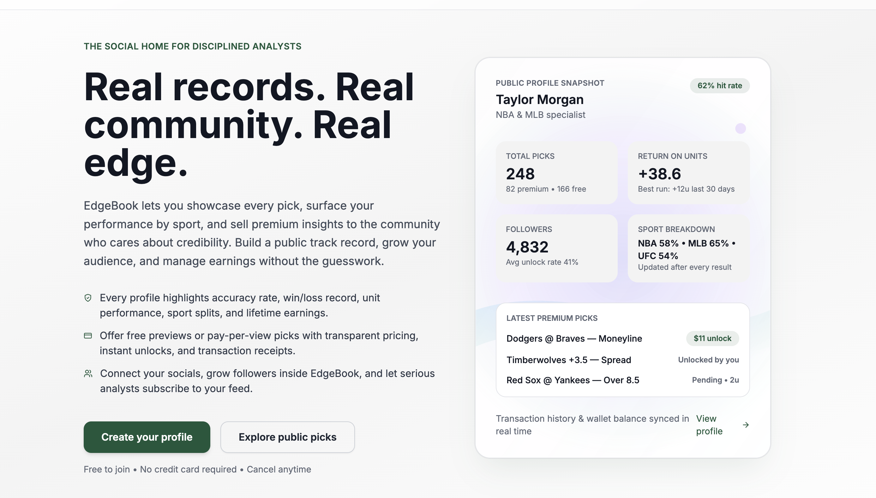

Hero: Center the text and make it bold (need to push the card to an H2 section) and simplify the message here.

**Think you’ve got the edge? Prove it!**

Showcase your picks, track results, and earn from your insight

Button (Primary): “Start Your Free Profile”

Link (not a button) below primary: “Browse Public Picks”

Something like this (horizontal layout under hero meesage):

Your Card

Winning % (ie 62%)

NFL & NBA Specialist

*Boost the numbers as you have and show them rolling/growing – make it float with a shodow, etc. like you have it looks great.*

Love this idea on the home page. Thought is to make this horizontal and under the Hero and sign up.

I would generalize this

Built for sports fans who predict outcomes

Post picks, share your card, prove your record, sell your insights.

|  |  |  |  |
| --- | --- | --- | --- |
| Profiles built on proof  Build trust instantly. Show your bio, socials, and verified stats so followers know your record is real. | Prediction posts that sell  Post free teasers or premium picks with proof of performance. Every result can be tracked for public record. | Payouts Simplified  Track earnings, create both subscriptions and per pick paywalls. All from one transparent dashboard. | Smart discovery for fans  Get discovered by followers, sort by sport or top earners, and rise up the leaderboard with every winning pick. |

Center the title

(Cant say settle bets). Post. Prove. Profit

Three steps from talking picks to earning from them.

|  |  |  |
| --- | --- | --- |
| Step 1 | Build your edge  Upload your photo, craft your bio, and connect socials.  Turn your record into your reputation.   * Win/loss tracking * Performance by sport * Verified credibility from day one | Step 2 | Share your picks  Post predictions with odds, notes, and confidence levels.  Offer free insights or premium picks that unlock instantly when purchased.   * Blurred previews for premium content * Upload models, screenshots, or clips * Grade your results (win/loss/push) | Step 3 | Get paid for your reputation.  Earn directly from your audience through a transparent platform and payout system.   * Instant payment support. * Manage and track earnings * Download all transactions |

It’s YOUR edge | we make it official

Delete the next two sections for now | Need to build additional functionality and start getting feedback from users:

Delete

Delete

Built on trust.

EdgeBook runs on transparency, security, and fair play, so creators and fans can focus on what matters: the picks.

|  |  |  |  |
| --- | --- | --- | --- |
| Age  18+ verification to ensure safeguards are in place. Keeping the community credible and compliant | Transparent payments  Every top-up, unlock, and payout is tracked in your dashboard with zero hidden fees and instant digital receipts. | Territory protection  EdgeBook adapts to your region, respecting privacy laws while keeping your data under your control. | Responsible gaming tools  EdgeBook is built to help you make smart decisions by giving you transparency in all public opinion. |

Join the community where picks become proof.   
Create your profile, post your first picks, and let your record do the talking.

Start Free Today | Sign In to EdgeBook  
  
18+ only. For entertainment and educational use.